Experiment 6

Aim of the Experiment: To implement the concept of rename, truncate, rollback and save point command using SQL.

Program:

Rename

Rename bcaiii to bca;

Selet * from bca;

Output:

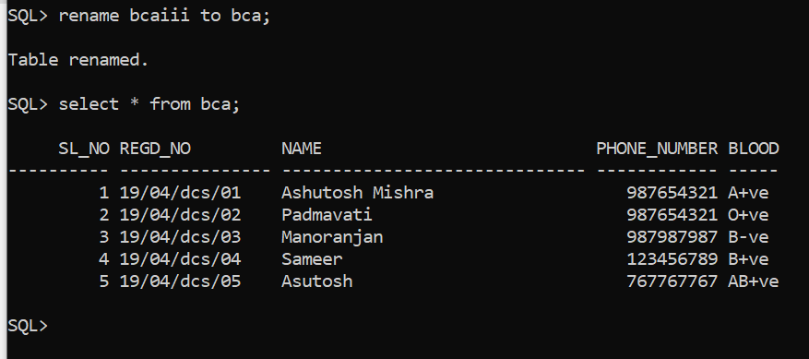

Rollback:

Program:

Delete from bca where sl_no=5;

Delete from bca where sl_no=4;

Rollback;

Output:

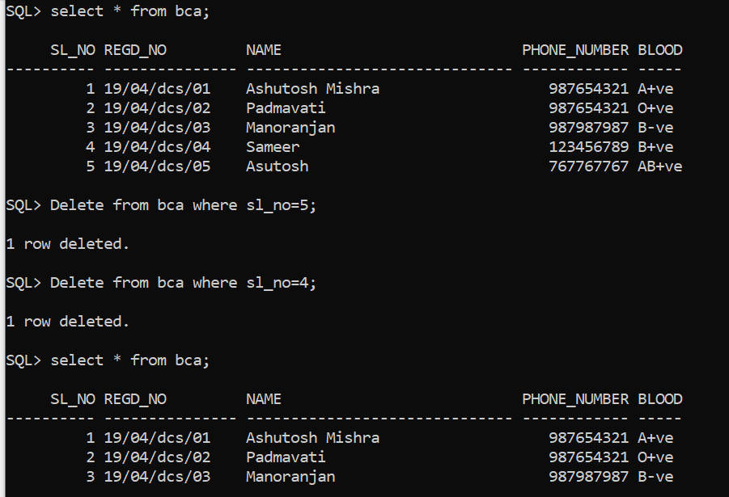

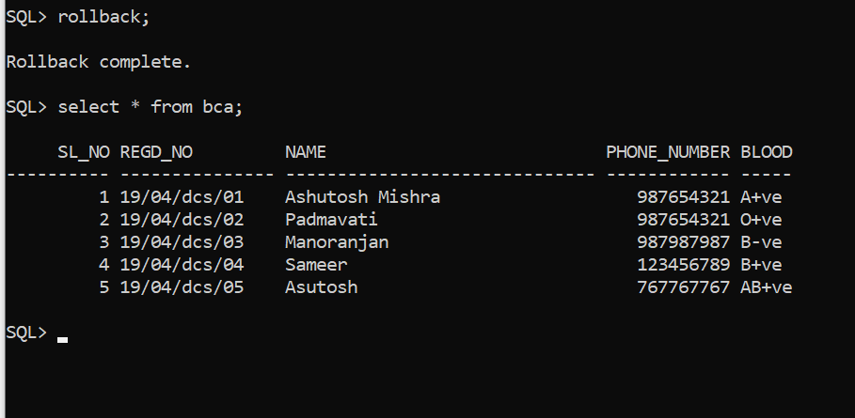

Truncate

Program:

Truncate table bca;

Output:

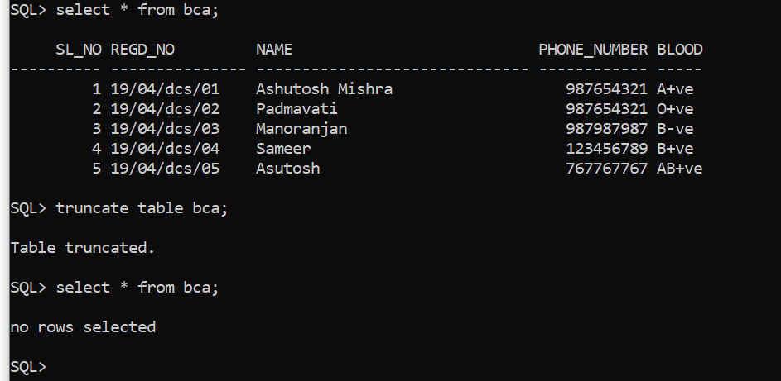

Save point:

Program:

Savepoint A;

